Modulation Depth and the Limits of Sharpness-Based Autofocus for Phase Objects
A Focused Study in Fourier Ptychographic Microscopy
Gaurang Garg
Healthcare Optics Research Group (H-ORG), Centre for Biomedical Engineering, IIT Delhi
2026

Abstract
Fourier ptychographic microscopy (FPM) reconstructs a high-resolution, wide-field image from low resolution multi-angle captures, but its reconstruction needs a initial estimate of sample defocus. The simplest way to obtain one is a sharpness search: propagate the data to several candidate planes and keep the sharpest result. This works well for stained, absorbing samples, but the unstained, transparent phase objects that FPM is most valuable for behave differently near focus, and the literature on the topic is scattered across digital holography, differential phase contrast, and FPM's own engineering practice, rather than assembled in one place. Using angular-spectrum simulation of an FPM system, we show that a common shortcut in computing a Brenner-style sharpness score manufactures spurious structure for phase objects; we quantify, in photon-budget terms, how fragile the resulting autofocus signal is to ordinary camera noise; we test two physically motivated fixes and show why one of them (oblique illumination) helps a trained estimator but not a greedy sharpness search, reconciling an apparent conflict with a recent published result; we extend the analysis to a much wider defocus range under a verified sampling bound; and we identify a single lens aperture, coincident with an already-known camera-matching condition, at which the autofocus signal is most resistant to noise. We also locate, directly and quantitatively, where a genuine diffraction phenomenon (Gibbs ringing) appears in this system, distinguishing it from an earlier, unrelated numerical artefact. A companion report treats the pedagogical background at length; this paper is self-contained and presents the argument and evidence on their own terms.

1. Introduction
A living, unstained cell absorbs almost no light; it mainly changes the light's phase, through small differences in refractive index between its interior and the surrounding medium. An ordinary camera measures only intensity, so such a phase object is invisible exactly at the plane where it is best focused, and becomes visible only once defocus has converted some of its phase structure into intensity contrast. Fourier ptychographic microscopy (FPM) is one of the capable tools built for this kind of sample: it stitches many low-resolution images, captured under sequentially varied LED illumination angles, into one high-resolution, wide-field, phase-resolving reconstruction. But that reconstruction is iterative and needs a working defocus estimate before it starts, and the founding FPM paper proposes, the most direct way to estimate defocus is to try several candidate values, reconstruct at each, and keep the sharpest.
This proposal has not, to our knowledge, been examined on its own terms for the case that actually matters most to FPM. In digital holographic microscopy (DHM), where the full complex field is captured directly, Dubois and colleagues proved rigorously that an amplitude-based focus criterion is minimised at true focus for an amplitude object and maximised for a phase object [3], later naming this a genuine practical difficulty, the criterion's polarity depends on object type and fixing it by operating on a high-pass filtered complex field [4], a fix independently rediscovered via a complex-field gradient sparsity measure [5] and documented as a general limitation of autofocus criteria across object types [6]. None of this transfers cleanly to FPM, because FPM (like any ordinary camera) only has intensity to work with before reconstruction, not the complex field DHM captures directly; the fix removes a bias term that, for an intensity-only phase-object measurement, is not a bias sitting on top of real structure but the entire signal. Inside FPM itself, defocus has instead been handled by joint pupil-aberration fitting [7], by a cross-angle consistency index distinct from any sharpness gradient [2], by dedicated autofocus hardware [8], and, increasingly, by trained single-shot regressors [9,10] -- a substantial and effective body of engineering that nonetheless leaves the founding paper's original, simplest proposal essentially untested against realistic noise for a phase object.
This paper closes that gap. Using a single, documented angular-spectrum simulation of an FPM-representative system, we (i) show that the precise numerical definition of a Brenner-style sharpness score determines whether it behaves sensibly at all for a phase object; (ii) quantify how much ordinary photon noise a sharpness search can tolerate before it fails; (iii) test, and correctly interpret, two candidate fixes for that fragility; (iv) extend the analysis safely to a much wider defocus range; (v) identify a single lens aperture at which the autofocus signal is most robust, and connect it to an independently known design rule; and (vi) locate where a real diffraction effect (Gibbs' phenomenon) actually appears in this system, having initially been suspected in the wrong place. A longer, pedagogically-oriented companion report develops the underlying optics from first principles for a reader new to the field; this paper assumes a working knowledge of Fourier optics and presents the argument on its own.

2. Theoretical Background
A thin sample is described by a complex transmittance O(x,y) = A(x,y)·exp[iφ(x,y)], where A is amplitude transmission and φ is phase delay. A pure phase object has A ≡ 1 and carries all its structure in φ; because a detector records only intensity, |O|² = 1 everywhere at the object itself, independent of φ. Propagating the field a distance z under the angular spectrum method multiplies its spectrum by exp[iz·k_z(f_x,f_y)], k_z = 2π√(1/λ² − f_x² − f_y²); recorded intensity then follows the Transport of Intensity Equation, ∂I/∂z ∝ −∇²φ, meaning phase curvature is converted into visible intensity only once z departs from zero. Any sharpness metric built on intensity -- most simply the Brenner gradient, B(z) = Σ(x,y)[I_z(x+2,y) − I_z(x,y)]² [11] -- therefore starts from an intrinsically weak signal at true focus for a phase sample, and grows away from it, opposite to the ordinary amplitude-object case where B(z) peaks at focus.
Two independent frequency limits bound what such a system can transmit. The objective admits spatial frequencies up to NA/λ; the camera pixel grid, of pitch p referred to the object plane, admits frequencies only up to 1/(2p). Whichever is smaller sets the system's effective bandwidth, and for the hardware used throughout this paper (λ = 0.532 μm, 2.5 μm pixels, 2× magnification) the two coincide at NA = 0.213 -- a crossover that recurs, for more than one reason, in the results below.
A separate and purely numerical constraint applies once defocus is simulated over a wide range: the propagation phase factor is a chirp whose local oscillation rate grows with z, and once that rate exceeds one half-cycle per grid sample, the discrete calculation aliases and silently returns an incorrect result -- the same failure mode as the stroboscopic wagon-wheel effect, here acting on the simulation rather than a camera. A band-limited correction that removes only the specific frequencies that would alias at a given z [12] keeps the calculation valid well beyond this naive bound, and is used wherever this paper reports results at large defocus.

3. Methodology
A single, fixed set of simulation parameters, summarised in Table 1, was used throughout; deviations are noted where they occur.
Parameter | Value
Wavelength | 0.532 μm
Magnification | 2.0×
Camera pixel pitch | 2.5 μm (1.25 μm at the object plane)
Lens/camera crossover NA | 0.213
Simulated capture grid | 128×128 px (main results), 256×256 px (extended-range results)
NA values tested | 0.05, 0.08, 0.10, 0.15, 0.20, 0.25, 0.40, 0.60
Default defocus range | ±50 μm (±300 μm for extended-range results)
Test objects were complex transmittance fields O = A·exp(iφc) built from a standard photographic amplitude pattern and a Gaussian-smoothed phase pattern, with c defining pure-amplitude, weak-phase, strong-phase, sharp-edged-phase, and two mixed amplitude/phase categories (Figure 1). Defocus was simulated by cropping the pupil-limited region of the object's spectrum, applying the propagation phase factor of Section 2 (with the band-limiting correction where noted), and inverse-transforming to intensity. Unless stated otherwise, sharpness was scored with the plain (unnormalised) Brenner gradient of Section 2, computed once per candidate z.
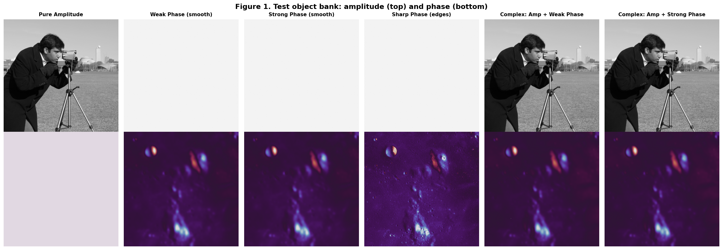
Figure 1. Test object bank: amplitude (top) and phase (bottom) channels of each category.
Five experiments were run on this pipeline: (a) a direct comparison of the plain Brenner gradient against a per-frame-normalised variant occasionally used for display purposes; (b) a Poisson shot-noise study measuring the fraction of trials in which the correct focal plane was recovered, at photon budgets from 20 to 5,000 per pixel, for on-axis illumination, for a fixed total budget split across an increasing number of exposures, and for oblique illumination; (c) a convergence check of the simulation grid itself, and a multi-scale check of curve shape near focus, run before trusting any fine-grained conclusion about curve shape; (d) a repetition of the main sweep over a ±300 μm range under the band-limited correction, together with a test of the dimensionless similarity variable ζ = z·NA²/λ suggested by the classical paraxial defocus aberration; and (e) a fine sweep of the ratio between the Brenner score's minimum and maximum across the sweep (its modulation depth) against NA, together with a direct, defocus-independent test for edge ringing at a sharp phase or amplitude step.

4. Results

4.1 Metric definition determines whether the signal is trustworthy
The plain and per-frame-normalised Brenner gradients disagree sharply for a weak phase sample at NA = 0.20: the normalised version shows a spurious double-peak the plain version does not (Figure 2). The true, unscaled contrast at focus is only about 0.025% of the peak found elsewhere in the sweep; rescaling every candidate image to a common display range erases this three-order-of-magnitude difference and can manufacture curve structure with no optical basis. All subsequent results use the plain definition.
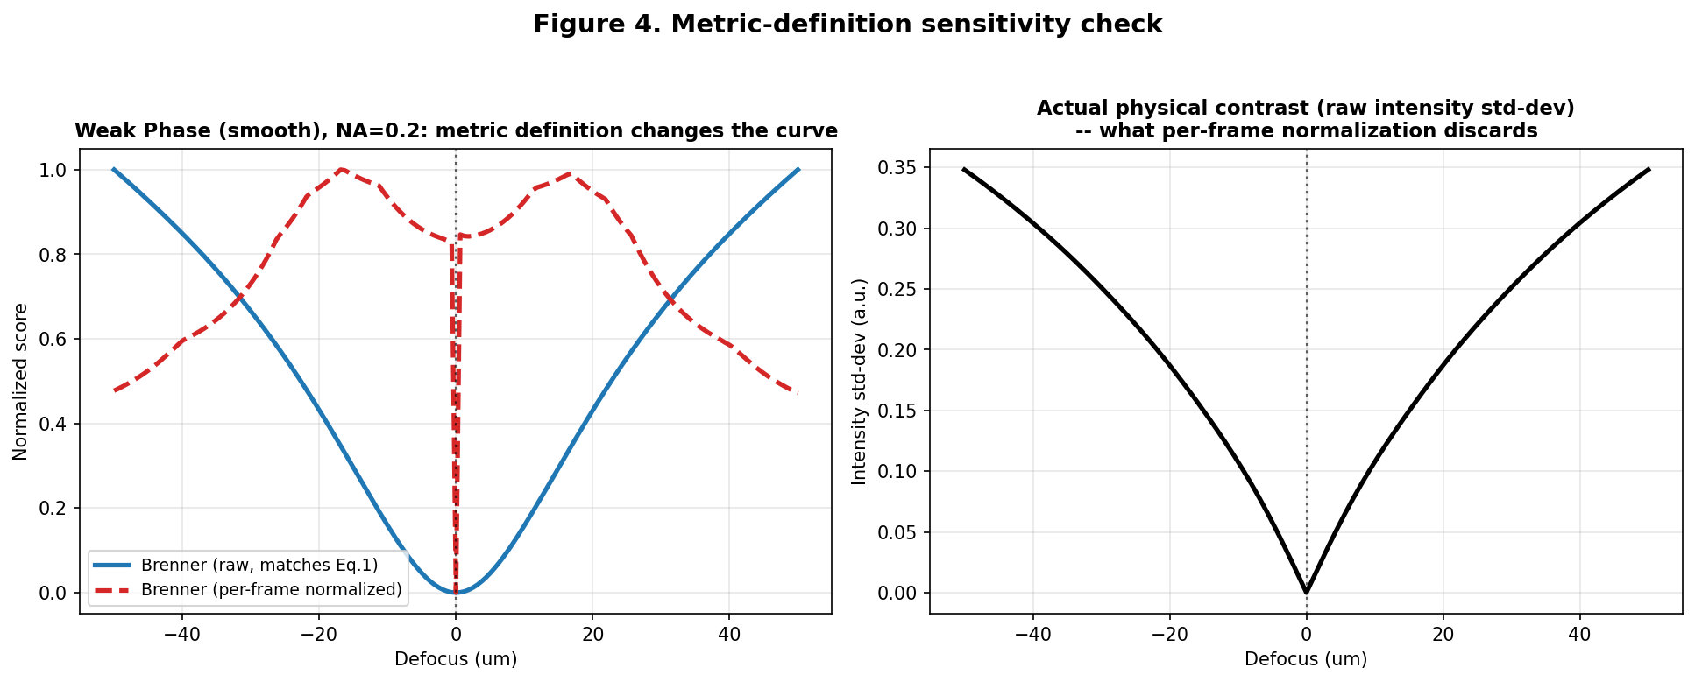
Figure 2. Left: plain (blue) vs. per-frame-normalised (red, dashed) Brenner curves for identical data. Right: the true physical contrast the normalisation discards.
With this definition fixed, the expected qualitative picture holds across the full object/NA grid: amplitude-bearing samples peak at true focus; phase samples dip there and rise on either side (Figure 3).
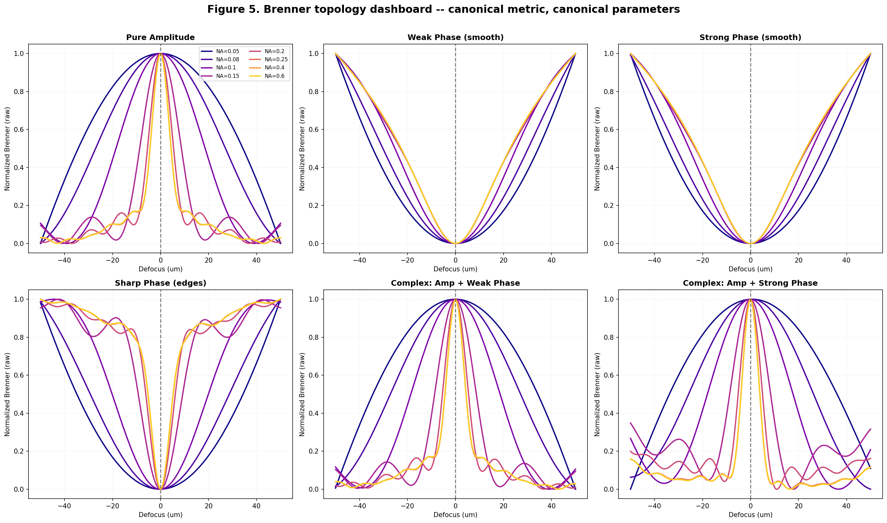
Figure 3. Brenner sharpness vs. defocus, all six sample categories, all eight tested NA values.

4.2 Noise robustness, and two candidate fixes
At 5,000 photons/pixel -- a generous budget -- a plain sharpness search recovered true focus for a weak phase sample in well under half of trials, because the in-focus signal is roughly three orders of magnitude below the sweep's peak and ordinary shot noise, shrinking only as the square root of photon count, is large enough to manufacture competing false minima before it is small enough to leave the true one visibly deepest. Splitting a fixed total photon budget across more exposures gave no systematic improvement (a direct consequence of Poisson statistics: summing K sub-exposures of a fixed total budget is statistically identical to one exposure of that budget). Oblique illumination, which raises in-focus contrast roughly five-hundred-fold by converting phase gradients into visible intensity independent of defocus, made the search less reliable, not more, at every budget tested (Figure 4).
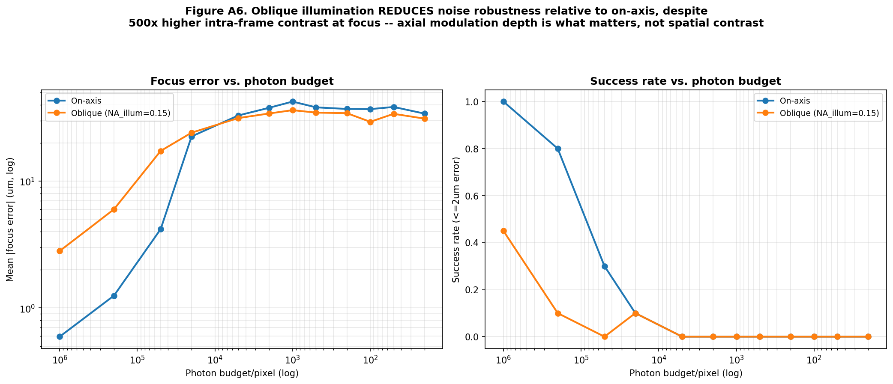
Figure 4. On-axis illumination (blue) recovers true focus at far lower photon budgets than oblique illumination (orange), despite the latter's much larger raw contrast.
The reason is that on-axis illumination gives a Brenner score at focus roughly one part in 10⁶ of its peak elsewhere -- an extremely deep, well-isolated minimum -- while oblique illumination raises the score across the whole sweep, not just at focus (consistent with the anti-symmetric weak-object transfer function of differential phase contrast [13]), leaving a shallower minimum (about 38% of peak) that is easier for noise to obscure despite its larger absolute signal. This appears to conflict with Pinkard et al.'s demonstration that oblique illumination enables accurate single-shot defocus prediction [9], but the conflict is only apparent: their method trains a regressor on the full Fourier-magnitude image rather than searching a scalar sharpness curve, and their own analysis identifies the same high-angle spectral information a greedy search cannot exploit. Oblique illumination carries genuine defocus information; extracting it requires an estimator built for the purpose, not a brighter but shallower input to an unchanged search.

4.3 Extended defocus range and a similarity law
Before trusting fine-grained curve shape at high NA, the simulation grid was checked for convergence (worst-case deviation under 11% between two tested resolutions) and the curve's local shape near focus was checked at three independent window widths; no sign change was found at any width, for any sample or NA, in the tested range. Extending the defocus range to ±300 μm under the band-limited correction reproduced the same qualitative picture as the ±50 μm range. Plotting every NA's curve against the dimensionless quantity ζ = z·NA²/λ, motivated by the classical defocus aberration term, produced a partial collapse onto one shape, clustering to within roughly a quarter of full curve height (Figure 5) -- consistent with ζ capturing the dominant behaviour, with the residual spread attributable to higher-order terms not included in the paraxial approximation.
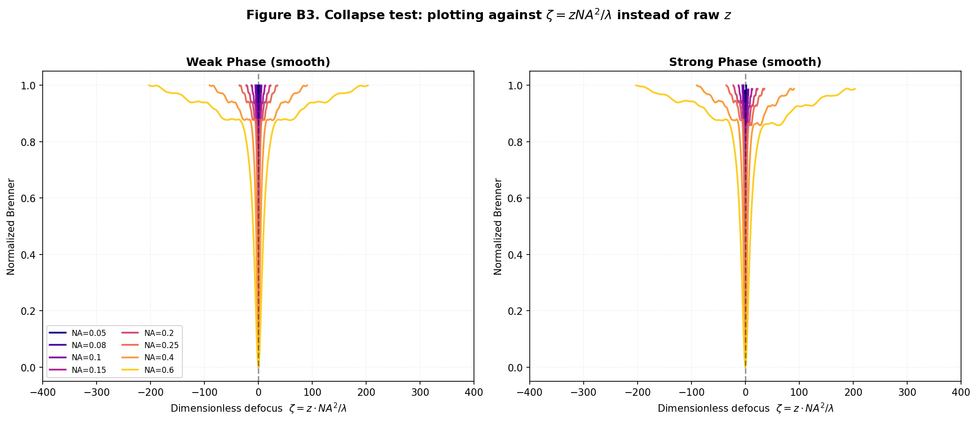
Figure 5. Sharpness curves for every tested NA, plotted against ζ = z·NA²/λ, for weak and strong phase samples.

4.4 A single aperture gives the most reliable signal
Modulation depth -- the ratio of the Brenner score's minimum to its maximum across the sweep, the quantity Section 4.2 identifies as governing noise robustness -- was measured as a function of NA directly. The relationship is non-monotonic: depth improves from low NA to a clear optimum, then degrades again at higher NA, where the camera Nyquist limit rather than the lens has become the effective bottleneck regardless of the nominal NA setting. A fine sweep locates this optimum at NA = 0.208 for a weak phase sample and NA = 0.241 for a strong one (Figure 6) -- both within a few percent of the 0.213 lens/camera crossover derived independently in Section 2.
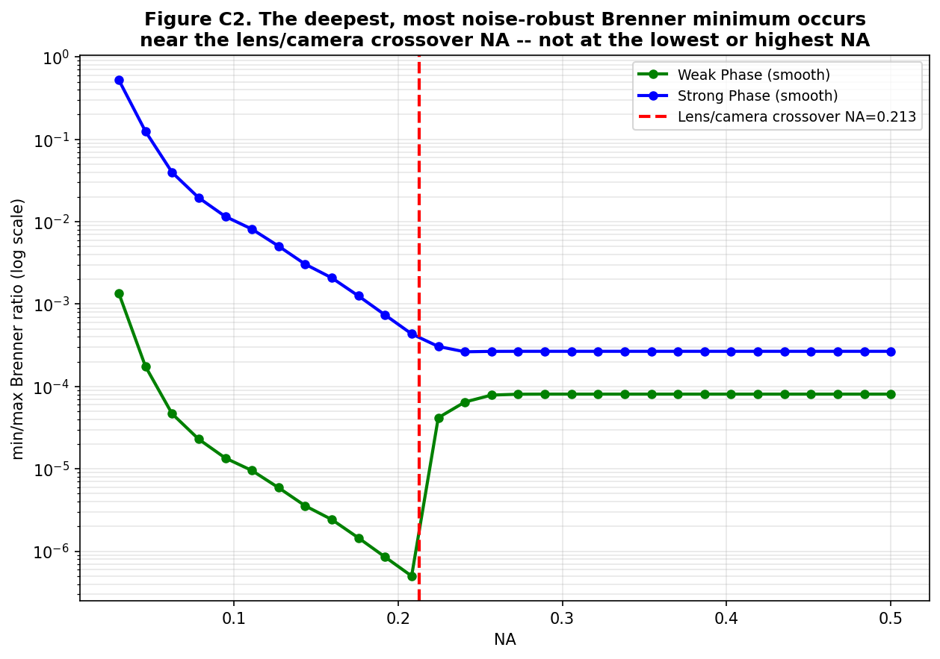
Figure 6. Depth of the true-focus minimum vs. NA. The optimum coincides closely with the independently-derived lens/camera crossover NA.
This connects two design conditions usually treated separately: matching illumination NA to objective NA for optimal phase-to-intensity transfer, established in the differential phase contrast literature [13], and matching objective NA to camera pixel size for optimal resolution transfer, a standard microscope design recommendation. The present result suggests these converge, for single-shot autofocus of a phase sample, on a single design point.

4.5 Locating Gibbs' phenomenon correctly
An earlier pass through this analysis had attributed an apparent change in curve character at high NA to Gibbs' phenomenon -- the fixed, roughly 9% overshoot that a sharp frequency cutoff produces near any discontinuity. That specific claim did not survive the checks in Section 4.3. Gibbs' phenomenon itself, however, is unavoidable mathematics given a hard-edged circular aperture, so its actual location was tested directly: a sharp phase-only edge (no amplitude change at all) was imaged at exactly zero defocus. Ringing was present immediately (Figure 7), with amplitude essentially fixed near 3.4% of baseline across NA = 0.1–0.6 -- the resolution-independent signature the mathematics requires -- and a width scaling closely with λ/(2·NA). The same test on an amplitude edge gave an intensity overshoot of 18.6–19.0%, matching the square of the classical 8.95% field-amplitude Gibbs constant almost exactly.
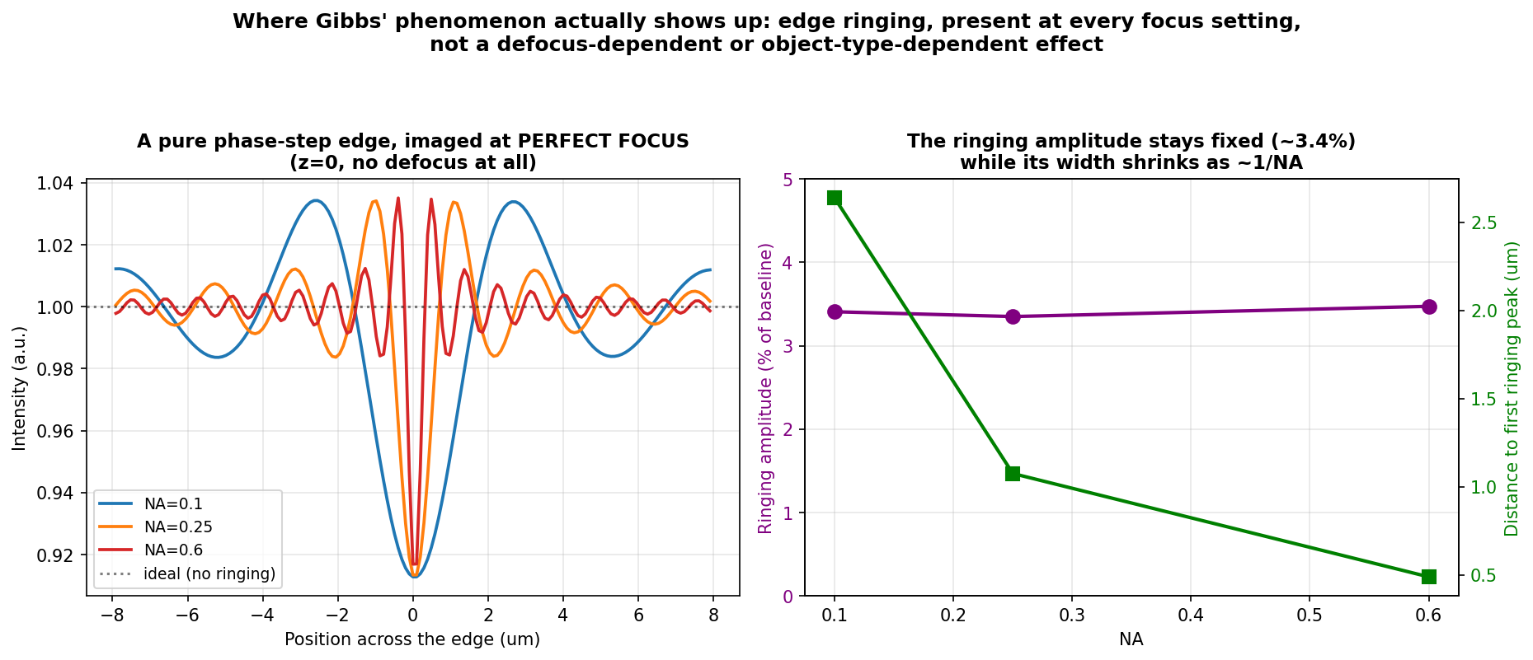
Figure 7. A phase-step edge at perfect focus already shows ringing, at fixed amplitude and shrinking width, across NA -- the two Gibbs signatures. This is unrelated to defocus.
Gibbs ringing in this system is therefore a small, fixed-percentage, focus-independent decoration on sharp edges -- present at every NA, including exact focus -- not a mechanism that reverses an aggregate sharpness curve's polarity at some special NA. It is also mechanistically distinct from the numerical aliasing of Section 2: aliasing shrinks toward zero with better sampling, while Gibbs ringing does not, and would persist even in an infinitely well-sampled simulation, disappearing only if the aperture edge itself were apodised.

5. Discussion
The five results above are most economically read as different consequences of one quantity: the modulation depth of the sharpness curve, i.e. how close it comes to zero at true focus relative to its peak elsewhere. Rescaling before measuring sharpness destroys this depth directly (4.1). Ordinary noise defeats a search precisely because the required depth is very large relative to achievable photon budgets (4.2), and neither tested fix restores it -- averaging leaves it untouched, oblique illumination actively shallows it, and both are consistent with the DHM-derived observation that intensity-only measurements retain none of the structure a complex-field-based fix removes (Section 1). The dimensionless collapse (4.3) shows depth-relevant curve shape depends on z and NA jointly rather than independently, and the NA optimum (4.4) shows depth is maximised exactly where two previously separate design conditions coincide. Gibbs ringing (4.5) is a separate, smaller-scale phenomenon that affects local edge structure, not the aggregate modulation-depth story the rest of the paper is built on -- worth distinguishing precisely so it is not mistaken for evidence either for or against the main argument.

6. Limitations
- The NA-matching result (4.4) was shown for one family of simulated phase structure and one hardware configuration; generality across object types and real optical systems remains to be tested.
- The noise and modulation-depth experiments used a representative subset of the full object×NA grid for computational reasons; the complete grid would strengthen the generality of the conclusions.
- The FPM patent family's cross-angle consistency index [2] was not compared against the Brenner-gradient family studied here; its modulation-depth behaviour, if any, is unknown.
- A Transport-of-Intensity-based direct defocus estimator, motivated throughout Section 4 as the natural alternative to a greedy sharpness search, was not implemented in this study.
- Reports of reduced accuracy for learned single-shot autofocus at low NA [9,10] were not tested against the modulation-depth framework developed here; whether the two are related is open.

7. Conclusion
Sharpness-based autofocus for phase objects in Fourier ptychographic microscopy is not simply less effective than for stained samples; it is governed by a specific, quantifiable property -- modulation depth -- that a careless choice of metric can destroy, that ordinary photon noise attacks directly because the required depth is very large, and that neither of two physically reasonable fixes restores, for reasons that reconcile rather than contradict recent published work. The same quantity is maximised at a single lens aperture that coincides with an independently known camera-matching condition, giving a concrete, testable design recommendation rather than only a diagnosis. A separate, smaller diffraction effect (Gibbs ringing) is real in this system but lives at sharp edges, at every focus setting, not in the aggregate curve the rest of this analysis is built on. Together, these results give Fourier ptychographic microscopy's oldest, simplest autofocus proposal a first-principles account of when it can be trusted, and a specific, physically motivated place to look next.

References
[1] F. Zernike, "How I discovered phase contrast," Science 121, 345-349 (1955).
[2] G. Zheng, R. Horstmeyer, C. Yang, "Wide-field, high-resolution Fourier ptychographic microscopy," Nature Photonics 7, 739-745 (2013); Fourier ptychographic imaging systems, devices, and methods, patent family (e.g. US 9,892,812; US 10,679,763).
[3] F. Dubois, C. Schockaert, N. Callens, C. Yourassowsky, "Focus plane detection criteria in digital holography microscopy by amplitude analysis," Opt. Express 14, 5895-5908 (2006).
[4] F. Dubois, A. El Mallahi, J. Dohet-Eraly, C. Yourassowsky, "Refocus criterion for both phase and amplitude objects in digital holographic microscopy," Opt. Lett. 39, 4286-4289 (2014); A. El Mallahi, F. Dubois, Opt. Express 19, 6684-6698 (2011).
[5] M. Tamamitsu, Y. Zhang, H. Wang, Y. Wu, A. Ozcan, arXiv:1708.08055 (2017).
[6] E. S. R. Fonseca, P. T. Fiadeiro, M. Pereira, A. Pinheiro, "Comparative analysis of autofocus functions in digital in-line phase-shifting holography," Appl. Opt. 55, 7663-7674 (2016).
[7] X. Ou, G. Zheng, C. Yang, "Embedded pupil function recovery for Fourier ptychographic microscopy," Opt. Express 22, 4960 (2014); A. Pan, C. Zuo, B. Yao, Rep. Prog. Phys. 83, 096101 (2020).
[8] J. Liao et al., Opt. Lett. 42, 3379-3382 (2017); C. Guo et al., Opt. Lett. 45, 260-263 (2020).
[9] H. Pinkard, Z. Phillips, A. Babakhani, D. A. Fletcher, L. Waller, "Deep learning for single-shot autofocus microscopy," Optica 6, 794-797 (2019).
[10] S. Jiang, J. Liao, Z. Bian, K. Guo, Y. Zhang, G. Zheng, Biomed. Opt. Express 9, 1601-1612 (2018).
[11] J. F. Brenner et al., "An automated microscope for cytologic research," J. Histochem. Cytochem. 24, 100-111 (1976); Y. Sun, S. Duthaler, B. J. Nelson, Microsc. Res. Tech. (2004).
[12] K. Matsushima, T. Shimobaba, "Band-limited angular spectrum method for numerical simulation of free-space propagation," Opt. Express 17, 19662-19673 (2009).
[13] L. Tian, L. Waller, "Quantitative differential phase contrast imaging in an LED array microscope," Opt. Express 23, 11394-11403 (2015).
[14] J. W. Goodman, Introduction to Fourier Optics, 4th ed., Macmillan (2017).
[15] G. Garg, "Why Transparent Cells Confound Autofocus: A Beginner-Friendly Review of the Fourier Optics Behind Defocus, Sharpness Metrics, and Autofocusing in Fourier Ptychographic Microscopy," companion report, H-ORG, IIT Delhi (2026).

